NSF Project: Creating Woodlands in Mali

Graduate Research Assistantships (2) available!

Funding will support two graduate assistants who will collaborate on the data collection and analysis through the duration of the NSF funded project and on the publication of the research findings. The students will assist during a maximum of two academic years. The graduate research assistants will work as field and/or lab research assistants for a maximum of 20 hours/week during the academic year with the option for more hours during summer. Tasks will vary but will likely include some the following:
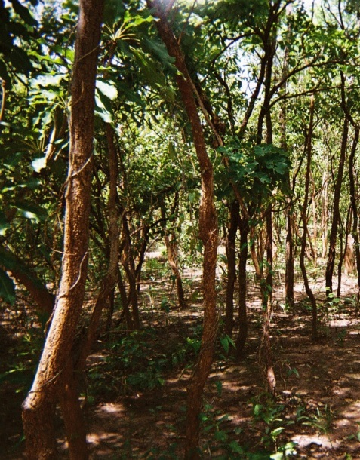
- Obtaining and classifying satellite and UAV generated imagery for the study area
- Storing and analyzing field and GPS data
- Fieldwork in Mali, Africa using a UAV to collect data on tree cover
- Creating maps and other visual representations of the data
- Writing methods sections for publication
- Conducting advanced GIS and/or statistical analysis of data sets
- Providing support for PI Laris and CoPI Lee on tasks related to the project

Requirements:

- Must be enrolled as a CSULB Masters student and be committed to conducting a thesis for the project.
- Must have experience in one of the following two areas:

Position #1, Remote sensing: GIS, Erdas and UAV experience required (GEOG 473, 475 and 485 or equivalents)

Position #2, Biogeography: GIS and advanced statistical analysis required (GEOG 400, 485 and 487A or equivalents)

- Knowledge of French language a plus!

For more information contact:

Dr. Paul Laris
Chair of Geography
CSU Long Beach
plaris@csulb.edu

