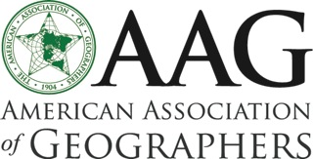 | 2016 Department Leadership Workshop  22 ~ 25 June, Knoxville, Tennessee

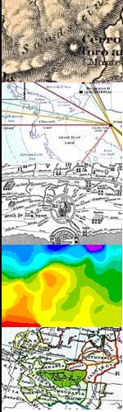
You are invited to the 13th annual workshop devoted to strengthening departmental leadership across the discipline. The workshop is for all geographers interested in improving their programs—chairs/heads, associate chairs/heads, deans, academic advisors, provosts and other administrators, as well as all faculty interested in leadership issues. The workshop is particularly well suited for individuals who may soon assume leadership positions.

The Department Leadership Workshop will begin on June 22, 2016 with an evening meal and orientation and end on Saturday, June 25, 2016 with breakfast and wrap-up (ending at 10:15 am)
10:15 am).

Registration for the Leadership Workshop is $350/person, which covers housing, supplies, meeting space, group transport, facilitator costs, and most meals. Participants are responsible for travel to and from Knoxville (including transport to and from TYS airport), one evening meal, and entertainment.

This Year's Theme

Departments are increasingly concerned with survival in a time of disruption in higher education. The theme for this summer will be building capacity to withstand change through strong management, shared governance, and deep understanding of the new rules of engagement. What are the measures of success for departments? How can departments strategically position themselves to generate student credit hours, attract diverse majors, support faculty research and publication, innovate in high-impact learning practices, and collect evidence that they are achieving these and other goals?

Other Topics

In addition to sessions on the workshop theme, time will be set aside for presentations and discussions on a wider range of topics of interest to department leaders such as:

- Strategic planning and self-study reports
- Recruiting for diversity and inclusion
- Social media and marketing
- Supporting mid- and late-career faculty

Time will also be set aside for participants to share and discuss their own concerns and experiences. One of the most important elements of the workshop is the opportunity it affords all participants to learn from and network with new and experienced leaders and administrators.

Participants will also have an opportunity to meet and share some meals with early career faculty attending the Geography Faculty Development Alliance workshop being held in Knoxville in the same week (http://www.aag.org/cs/early-career-workshop).

Additional Information
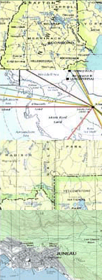
Program Committee

With the help of past participants and leaders, the program and schedule for the workshop is being developed by Sarah Witham Bednarz, former associate dean and AAG president (2015-16).

Cost, Registration, Accommodation, and Travel

Registration for the Leadership Workshop is $350/person, which covers housing, supplies, meeting space, group transport, facilitator costs, and most meals. Participants are responsible for travel to and from Knoxville (including transport to and from TYS airport), two evening meals, and entertainment.

Please register at:
http://www.aag.org/cs/department-leadership-workshop

A room will be reserved for you when you register for the conference. Your room will be confirmed before you arrive.

McGhee Tyson Airport (TYS) is about 15 miles from the University of Tennessee campus and is the closest airport to the university. A number of taxis companies serve the airport, Knoxville, and the university (http://www.tys.org/tys/pay-us-a-visit/taxis-limousines-and-buses/).

The University of Tennessee at Knoxville is the preeminent research-based, land-grant university in the state. The university is located near several area resources, including Oak Ridge National Laboratory, Great Smoky Mountains National Park, Beck African American Museum and Cultural Center, Worlds Fair Park, Ijams Nature Center, and Dollywood. Knoxville has a revitalized downtown with shops, restaurants, historic theaters, museums, art galleries, and an outdoor farmer’s market—all a few blocks from campus.

A stand-alone unit for almost 50 years, the Department of Geography at the University of Tennessee offers B.A., M.S., and Ph.D. degrees. Workshop activities will be held in the Burchfiel Geography Building, built for the Department in 2000 and centrally located on campus next to the university’s new student union. Visitor information is available from http://www.visitknoxville.com/, http://www.tnvacation.com/east/

If you have questions about the workshop program, please contact Sarah Bednarz, s-bednarz@tamu.edu.

If you have questions about registration or payment, contact AAG Conference Director, Oscar Larson, olarson@aag.org or 202-234-1450.

About the Healthy Departments Initiative

The workshop is part of the Healthy Departments Initiative launched by AAG Past President Vicky Lawson to strengthen leadership and administrative skills among geographers. The project has organized a series of workshops to facilitate sharing of successful strategies for maintaining healthy departments. The Healthy Departments website (http://www.aag.org/healthydepartments) is intended as a resource to assist leaders by providing practical resources and information that can improve program quality.

