2018 Landscape Photography Competition
Sponsored by the Landscape Specialty Group

Overview:
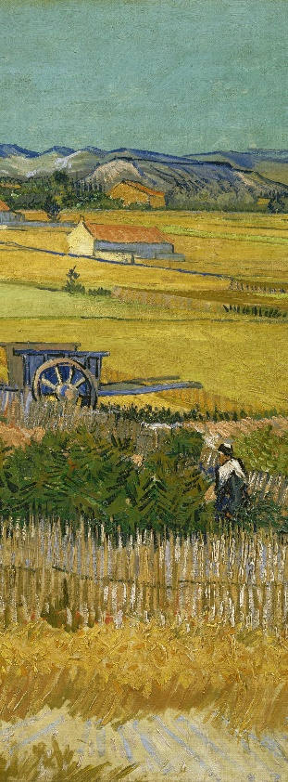
The Landscape Specialty Group (LSG) of the AAG is pleased to announce the 2018 competition for the best photo or map that captures the concept of landscape -- whether human, physical, or virtual in nature. LSG's primary objectives are visually communicating the varied nature of what landscape means to geographers as well as to provide researchers an opportunity to share with the community the magnificence of the landscape(s) that they study.
Figure 1: Original artwork Vincent van Gogh's Field with Poppies, digital re-rendering by Kelley A. Crews
Requirements:
All LSG members are eligible, regardless of career stage status. Each LSG member may submit up to two entries (per competition) that have ideally not be altered in any desktop image processing program such as Photoshop. Submissions must be in the original size or not smaller than 1000 pixels in either height or width. Each photo /map submission should include a caption (maximum 150 characters).
All photos or posters should be printed out in order to be presented at the AAG Meeting. Applicants should also prepare a brief presentation (~5 min) about the story behind your photograph or map and its connection to landscape.
Prizes:
The winner will receive $250, with the image displayed on LSG’s website. The runner up will receive $100. The results will be announced at the LSG’s annual business meeting. The committee reserves the right to offer no prize(s) if the submissions are not of appropriate quality.
Due date:
The next deadline is November 8, 2018. Please email the photo, your name, your AAG ID number, and detailed contact information to the Awards Director of the LSG, Kate Markham katemarkham@u.boisestate.edu. You should also indicate if you have edited your submission in Photoshop or in some other manner. Please be sure to use "LSG Photo Competition" as the subject line for your email.
Judging:
The submitted photos and maps will be judged by the LSG’s executive committee.
Use of images & disclaimer:
By submitting, the entrant certifies that 1) the entry is his/hers only and 2) LSG has the right to post the photo/map online indefinitely and free of charge. Copyright and all other rights remain that of the photographer/cartographer. Any image used by the LSG shall carry the creator’s credit line.

